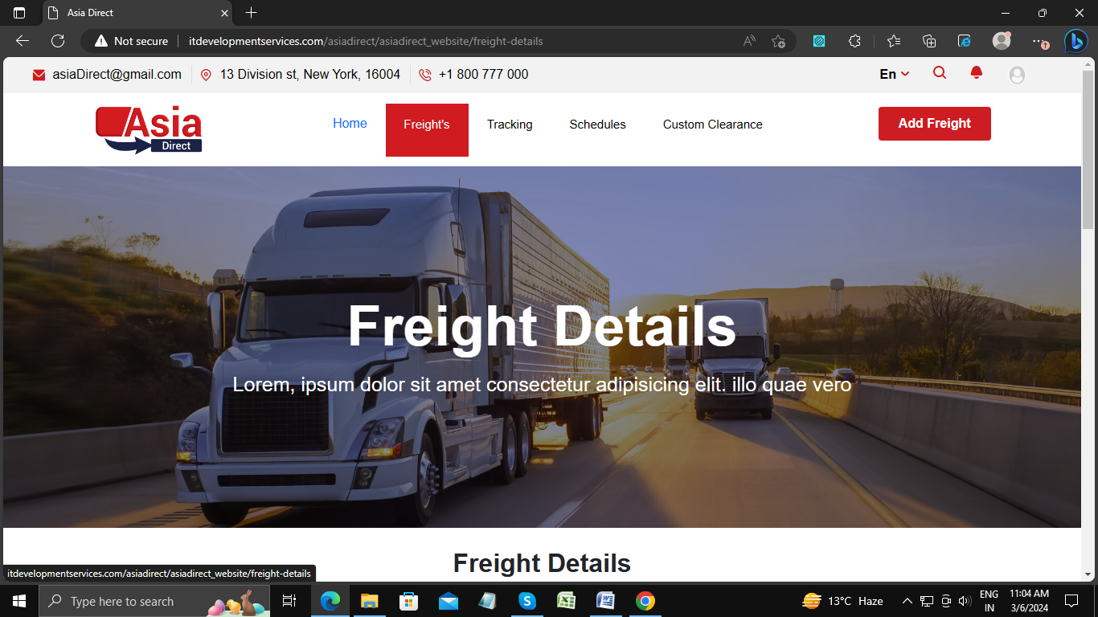

When I navigate from home page to any other page then it will highlight.

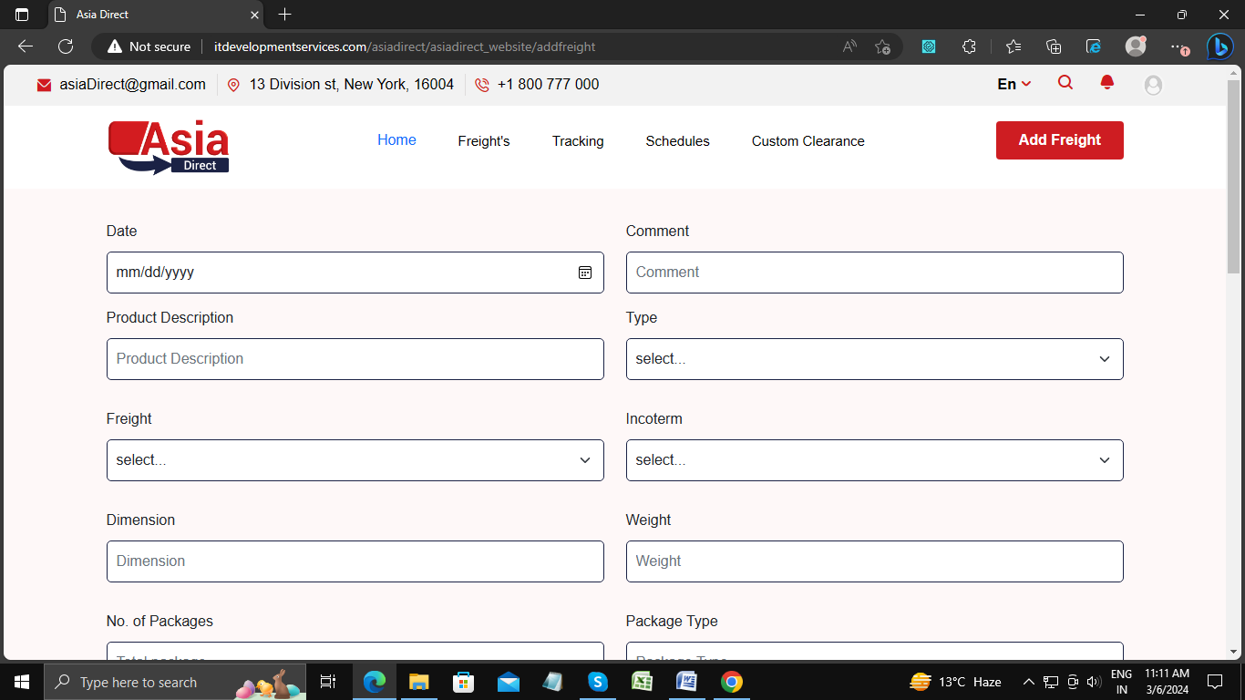

Remove “Add Frieght” from here

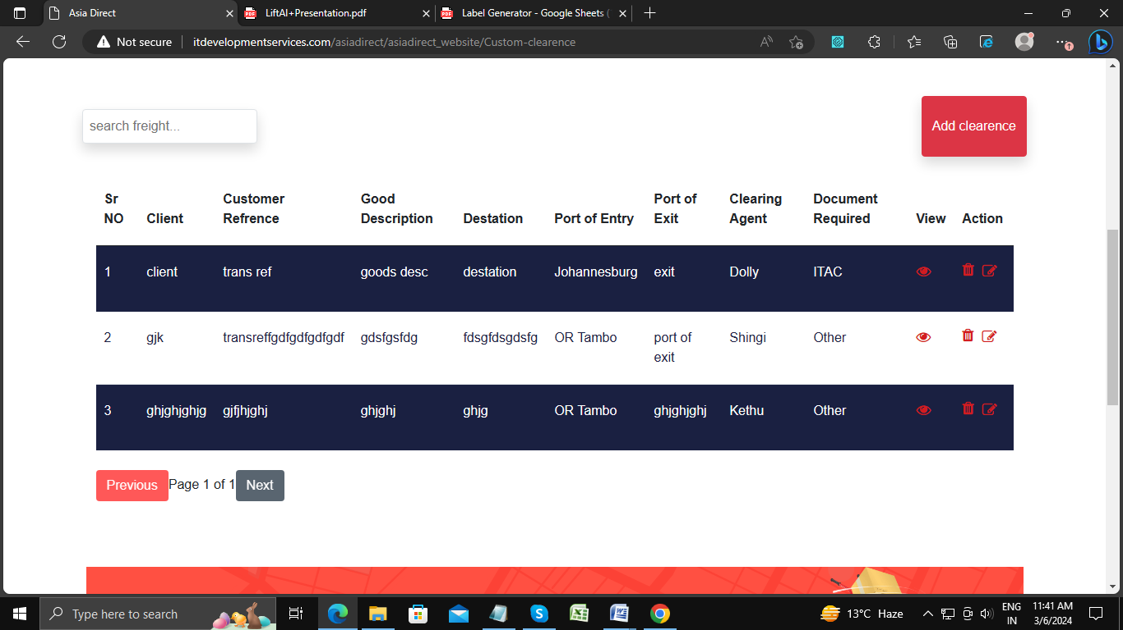

Search input box is not aligned properly.

Put first letter capital of “search freight”.

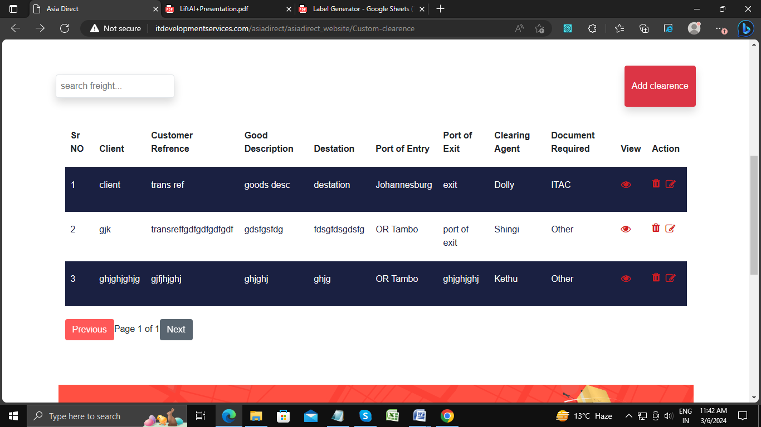

Make proper space between all heading’s

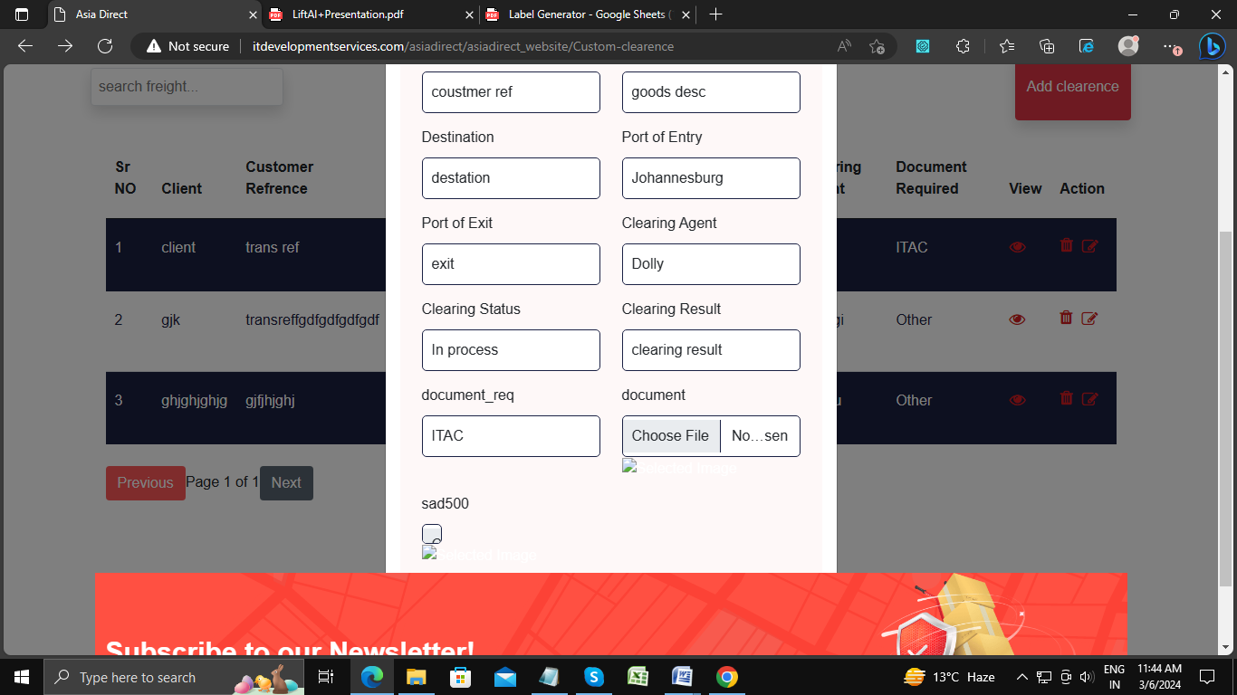

Make proper design

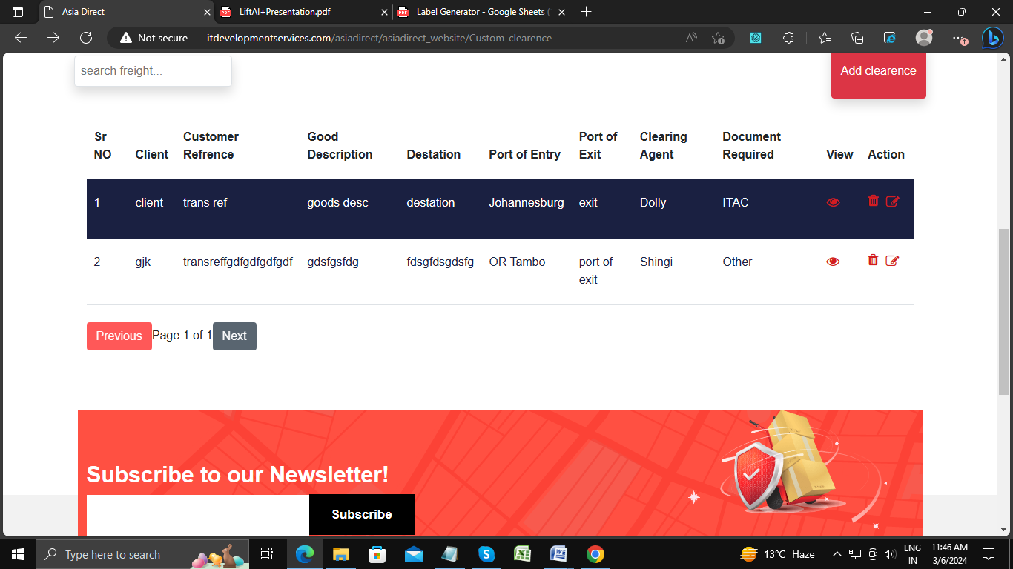

Put confirmation dialog box for delete button.